**IONIC FRAMEWORK**

1. SETUP

- You can refer <http://ionicframework.com/docs/guide/installation.html> to setup ionic framework.

1. Install Node.js server

Link download v4.4.2 : https://nodejs.org/en/download/

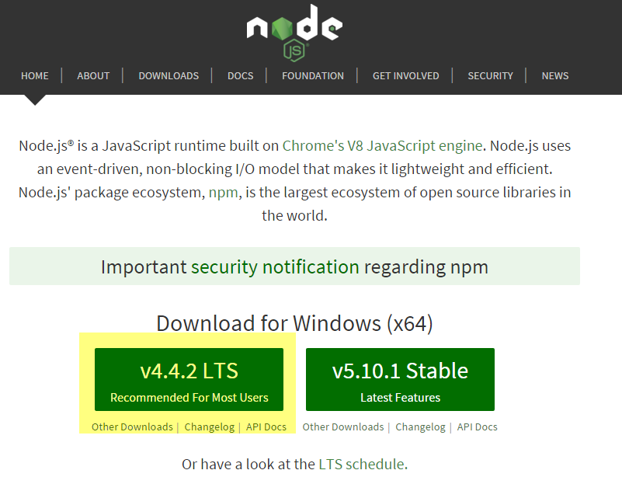

1. Run Node.js command line as Administrator

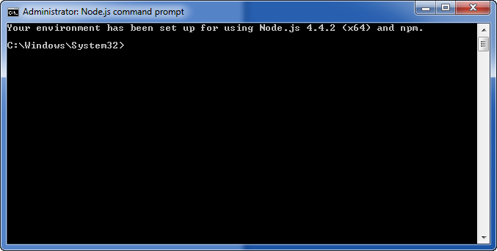

1. Install Ionic

- Run : npm install -g ionic@beta

1. Checkout source

Download and install Github app

Checkout source code

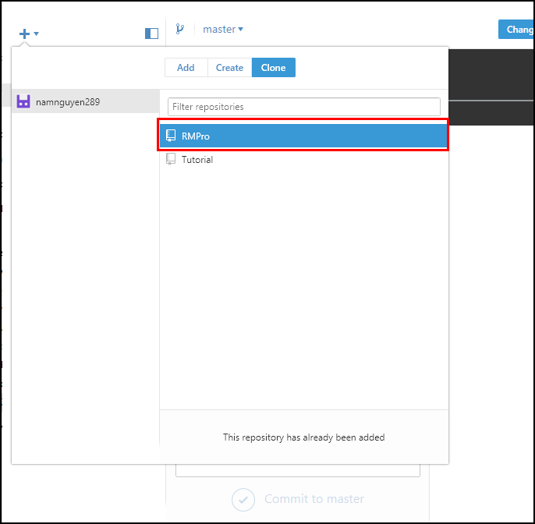

1. RUN PROJECT
2. Start file server

- You should go to folder contain project ex:

D:\Learning\ionic\RMPro\RMPro\Source Code

Run: **startFileServer.bat**

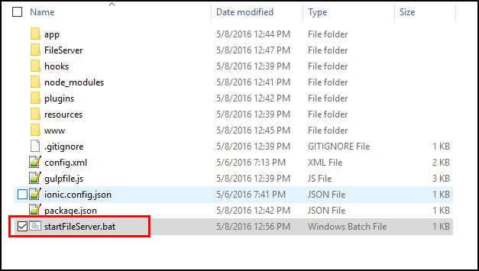

1. Start App server

Open command on your project folder

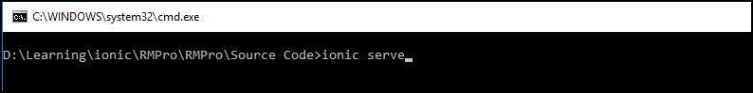

Run : ***ionic serve***

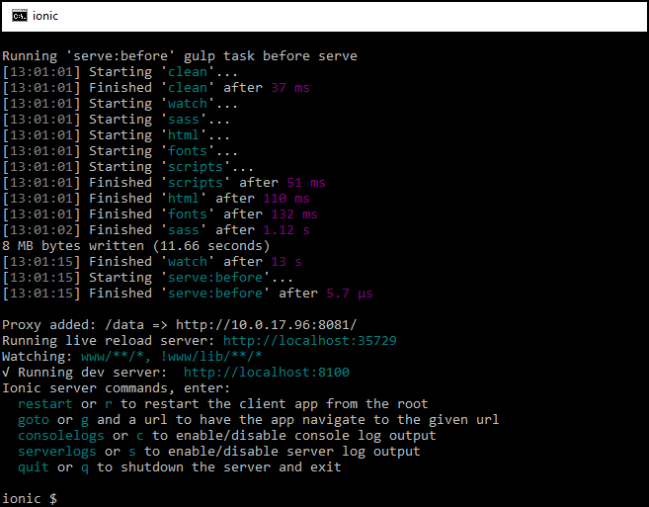

1. System will be automatic run project on browser

With default port: 8100

That’s better when you open development mobile mode

